TRAVEL INSURANCE PLAN FOR STUDENTS PROJECT

Software Requirements Specification

|  |  |  |  |
| --- | --- | --- | --- |
|  | Prepared By | Reviewed By | Approved By |
| Name | Mekala Rakesh Babu | Deva Thilagai |  |
| Role | InternsI | Batch Trainer |  |

**Table of Contents**

Table of Contents…………………………………………………………..….......II

1. Introduction…………………………………………………………………..…1

1.1 Intended Audience……………………………………………….......1

1.2 Project Scope…………………………...……………………………1

2. Overall Description…………………………………………….……………….1

2.1 Operating Environment……………………...……………………....1

3. Requirements……………………………………………………………...…….1

3.Policy Bazaar…………………………………………………………….2

3.1.1 Functional Requirements……..…………………………...2

**1. Introduction**

P3olicy Bazaar website is an online platform that offers a wide range of insurance products and services to individuals and businesses. We are taking and testing some functionalities of that website(i.e.) Travel Insurance plan for students.

**1.1 Intended Audience**

Business Unit (BU) SME

Academy coach

Technical Trainer

**1.2 Project Scope**

This document defines at a functional level the business activities that are encompassed by the system and the rules that apply to them. It also encompasses some of the key high- and low-level technical requirements of the system.

It draws heavily on both proposed Framework and Business Rules and the Technical Architecture documents. The scope of the detailed analysis project phase specifies that this document will include.

· Classification of requirements according to their functional areas.

· A description of each process in the system, including their inputs, outputs, and data transformation rules.

**2. Overall Description**

**2.1 Operating Environment**

Windows operating system

Web application

**3. Requirements**

This part of the requirements document serves to present the” travel insurance plan for students”.

**3.1.1 Functional Requirements**

**3.1.1.1 Req0001**

**Req0001a-**The user navigates to policy bazaar website and clicks on the travel insurance icon.

**Req0001b**-The user selects the destination, trip duration, no of travelers and age of travelers .

**Req0001c-**The user selects the pre-existing medical condition and enters the mobile number.

**Req0001d-** The user selects the students plan and sort the results from low to high price.

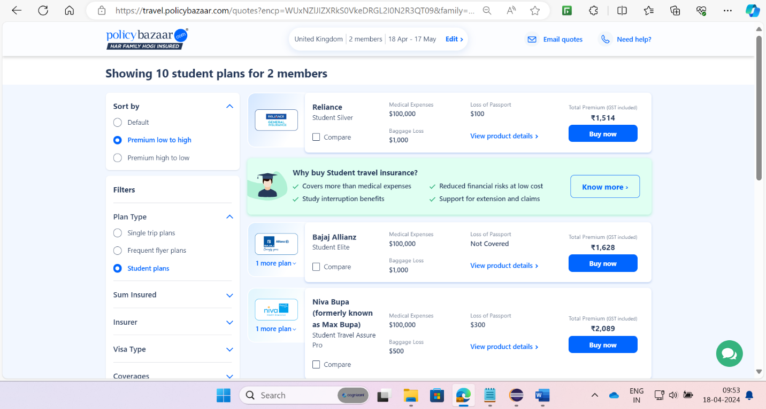 **Req0001e-** Displays the result and capture three lowest international travel insurance plan with amount and insurance provider company.

**3.1.1.2 Req0002**

**Req0002a**- The user navigates to policy bazaar.

**Req0002b-** The user hovers on Insurance Products in the nav bar.

**Req0002c-** Displays the Health Insurance products menu Items and capture them.

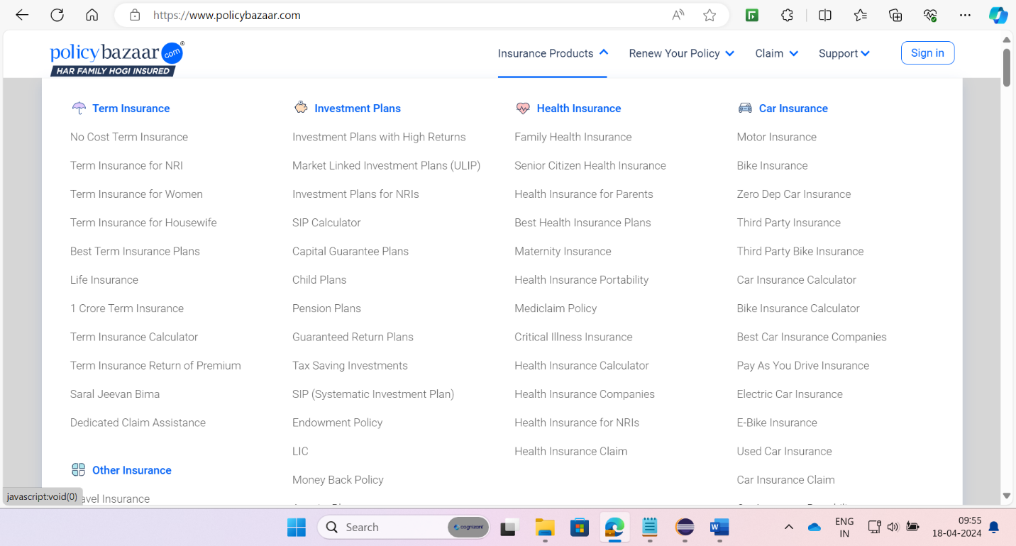

**3.1.2.3 Req0003**

**Req0003a**-The user navigates to policy bazaar and click on the Car Insurance Icon.

**Req0003b-** The user selects buying a new car.

**Req0003c-**The user selects City, RTO, Car brand, Car model, Car fuel type and variant.

**Req0003d-**The user enters the required details and capture the error messages.

